The UK Nuclear Industry Good Practice Guide To:

Appropriate Conservatism
in
Safety Cases

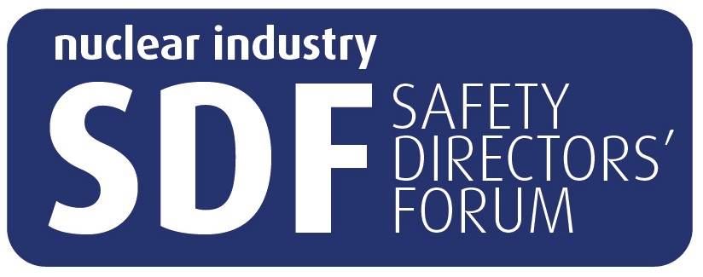

This Nuclear Industry Good Practice Guide was produced by the Safety Case Forum and published on behalf of the Nuclear Industry Safety Directors Forum (SDF)

[MONTH] [YEAR]
Revision History

Issue Number | Revision Date | Changes

It is recognised that – through the experience of using these Guides – there may be comments, questions and suggestions regarding its contents.

In the first instance, any such comments should be sent to the following

[INSERT CONTACT DETAILS HERE]

Foreword
Executive Summary for the contents and subject matter discussed within the Guide

Safety Directors Forum
In a sector where safety, security and the protection of the environment is, and must always be the number one priority, the Safety Directors’ Forum (SDF) plays a crucial role in bringing together senior level nuclear executives to:

- Promote learning;
- Agree strategy on key issues facing the industry;
- Provide a network within the industry (including with government and regulators) and external to the industry;
- Provide an industry input to new developments in the industry; and,
- To ensure that the industry stays on its path of continual improvement.

It also looks to identify key strategic challenges facing the industry in the fields of environment, health, safety, quality, safeguards and security (EHSQ&S) and resolve them, often through working with the UK regulators and DECC, both of whom SDF meets twice yearly. The SDF members represent every part of the fuel cycle from fuel manufacture, through generation to reprocessing and waste treatment, including research, design, new build, decommissioning and care and maintenance. The Forum also has members who represent the Ministry of Defence nuclear operations, as well as “smaller licensees” such as universities and pharmaceutical companies. With over 25 members from every site licence company in the UK, every MoD authorised site and organisations which are planning to become site licensees the SDF represents a vast pool of knowledge and experience, which has made it a key consultee for Government and regulators on new legislation and regulation.

The Forum has a strong focus on improvement across the industry. It has in place a number of subject-specific sub-groups looking in detail at issues such as radiological protection, human performance, learning from experience and the implementation of the new regulatory framework for security (NORMS). Such sub groups have developed a number of Codes of Practice which have been adopted by the industry.

Sub-Group Description
This document is produced by the Safety Case Forum, which is a sub-group of the Safety Directors’ Forum. The Safety Case Forum was established in June 2012 and brings together a wide range of representatives of nuclear operators, from all the Licensees and Authorisees across the United Kingdom, including:

- Civil, commercial and defence activities;
- Design, operation and decommissioning of nuclear facilities;
- Research facilities.

The purpose of the Safety Case Forum is to provide guidance that is useful to, and will benefit the widest possible range of UK nuclear operators.

Such guidance is not mandatory, nor does it seek to identify minimum standards. It aims to provide a tool kit of methods and processes that nuclear operators can use if appropriate to their sites and facilities.

These guides are intended to improve the standardisation of approach to the delivery of fit for purpose safety cases, while improving quality and reducing the cost of production. They are designed to cater for all stages of a facility’s life cycle and for all processes within that life cycle. This includes any interim, continuous and periodic safety reviews, allowing for the safe and efficient operation of nuclear facilities.

When using the information contained within these guides, the role of the Intelligent Customer shall always remain with the individual nuclear operator, which shall retain responsibility for justifying the arguments in their respective Safety Cases. The Office for Nuclear Regulation is a consultative member of the Safety Case Forum.

The following companies and organisations are participating members of the Safety Case Forum:

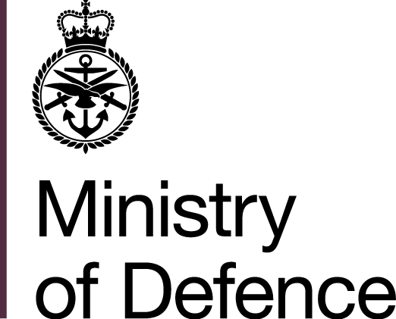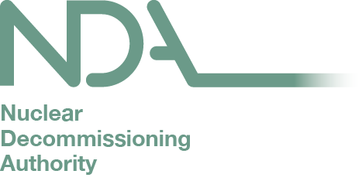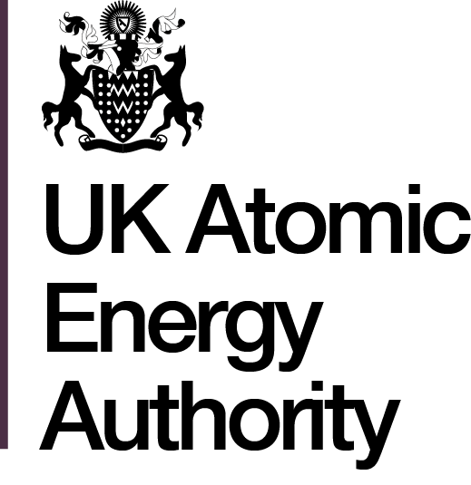

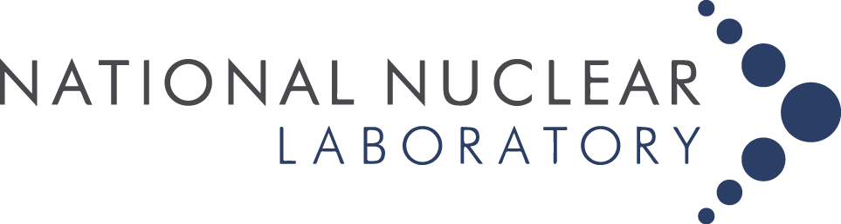

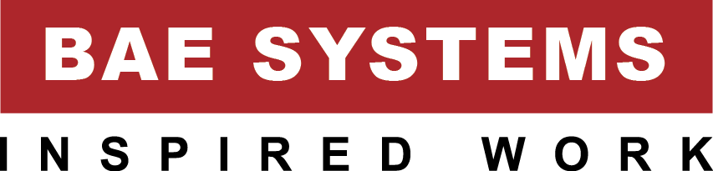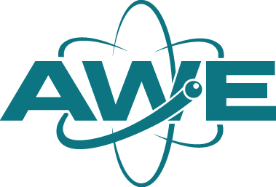

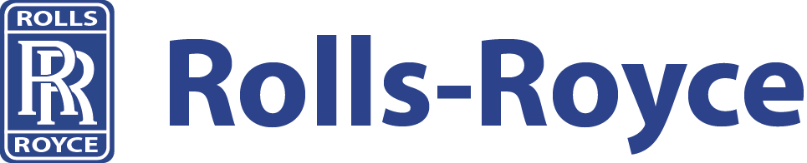

Disclaimer

This UK Nuclear Industry Good Practice Guide has been prepared on behalf of the Safety Directors’ Forum. Statements and technical information contained in this Guide are believed to be accurate at the time of writing. However, it may not be accurate, complete, up to date or applicable to the circumstances of any particular case. This Good Practice Guide is not a standard, specification or regulation, nor a Code of Practice and should not be read as such. We shall not be liable for any direct, indirect, special, punitive or consequential damages or loss whether in statute, contract, negligence or otherwise, arising out of or in connection with the use of information within this UK Nuclear Industry Good Practice Guide.

This Good Practice Guide is produced by the Nuclear Industry. It is not prescriptive but offers guidance and in some cases a toolbox of methods and techniques that can be used to demonstrate compliance with regulatory requirements and approaches.

Contents

Revision History ii
Foreword iii
Safety Directors Forum iv
Sub Group Description iv
Disclaimer vi
Contents vii
Introduction 1
Aims 1
Scope 1
Terminology 1
Application/Readers Guide 1
Introduction to Subject Matter 2
Relevant legislation 2
Guiding Principles/Concepts 3
Main Body 4
Summary of Key Points 5
Appendix A – Good Practice Examples 6
Appendix B 6
Glossary 7
List of SDF Publications 8

Introduction

Aims

Scope

Terminology
[Should be limited to a few specific terms]
A full glossary of terms used is available at the back of this Guide

Application/Readers Guide

Introduction to Subject Matter

Relevant legislation
This document has been generated with consideration of relevant health and safety legislation. Where appropriate legislation has been referenced, but the primary legislation that has influenced this document is:

Guiding Principles/Concepts

Main Body

Summary of Key Points

Appendix A – Good Practice Examples

Appendix B

Glossary

Term | Definition

List of SDF Publications

Codes of Practice

Best Available Techniques for the Management of the Generation and Disposal of Radioactive Wastes
Changeroom Design, Operation and Maintenance
Clearance and Radiological Sentencing
Management of Change and the Nuclear Baseline
Good Practice Guides

Independent Oversight – A Nuclear Industry Good Practice Guide
Personnel Dosimetry Management
The Application of ALARP to Radiological Risk
The Selection of Alarm Levels for Personnel Exit Monitors
Other Guidance

An Aid to the Design of Ventilation of Radioactive Areas
An Aid to the Design of Ventilation of Radioactive Areas
Best Practice on Peer Review Case Submissions
Conservative Exposure Durations for Unmitigated Worker Doses in Design Basis Analysis
Key Attributes of an Excellent Nuclear Security Culture
Right First Time Safety Cases: How to Write a Usable Safety Case
Conservative Exposure Durations for Unmitigated Worker Doses in Design Basis Analysis

