Application Form

The Nuclear Institute Scotland Branch, in association with the Young Generation Network, invites you to take part in the 2023:

Presentation Competition for Young Speakers

Wednesday 14th June 2023,

This year’s competition will be held via
Online webinar, with the winner taking part in person at the national final in September in London*.

Sponsored by:
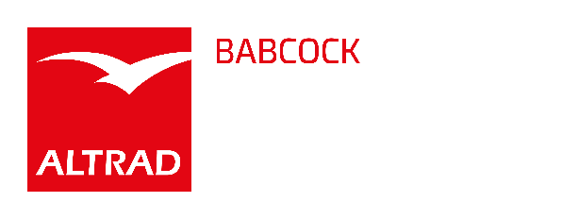

1st Prize - £300*
2nd Prize - £200
3rd Prize - £100
and a place in the national final*

Synopsis prize draw - £100

*Finalists could be offered £50 towards their travel

The Competition
The competition is open to everyone under the age of 37 at the time of the competition (i.e. those eligible to be members of the NI Young Generation Network). The competition is open to members and non-members of the NI.

The Subject Matter
We encourage you to present a talk on any topic directly related to “the nuclear industry”. We hope that this scope will encourage those of you new, or thinking of entering the industry to have a go. For those of you wishing to present a “commercial / sensitive topic”, can we remind you of the importance of obtaining permission from your employer.

The Experience
The object is to encourage you to gain valuable experience in speaking before an audience. Emphasis is placed on presentation! Winners will be offered free presentation skills training in August and the national final winner will receive a place at the YGN Annual Dinner and the opportunity to present at the day seminar.

The Application
All you have to do at this stage is submit a title and 200-word synopsis using the application form overleaf. The 200-word synopsis will give the judges a flavour of what to expect with all synopses being entered into the prize draw. The best five synopses, as judged by the organising committee, will be invited to contest the competition via online webinar.

The Marking Scheme
Each presentation must last no more than 10 minutes (you will be stopped at the 10 minute mark) and each competitor is to be given a maximum of 5 minutes to answer any questions from the judges or audience.

The marking scheme is:

Content of the presentation (relevance to topic): 10
Oral presentation and talk construction: 20
Clarity: 10
Handling of Q&A: 10

PRESENTATION COMPETITION FOR YOUNG SPEAKERS

Wednesday 14th June 2023

APPLICATION TO PARTICIPATE

Please complete and return along with your 200-word synopsis (to arrive by Friday 19th May) to Alan Ruiz by emailing:

alan.ruiz@consultarc.com

I wish to be considered to present at the above competition.

NAME……………………. …………………………………………………………..

COMPANY/UNI/COLLEGE ……………………………………………...……………..

ADDRESS………………………………………… …..………………………………

……………………………………… POST CODE………………………..………...

TELEPHONE…………………………….. FAX…………………………………..…….

E-MAIL ADDRESS……………………………………………………..……………….

TITLE OF PRESENTATION…………………………………………………..…………...

SYNOPSIS (maximum of 200 words):

Participation in this event can count towards your Continuing Professional Development.

The competition commences at 6pm.

Webinar details will be issued closer to the event.

Event kindly sponsored and hosted by:

